Nicholas Schuhmacher
- Define and prepare a sample of a use case and a use case diagram. (5 points)
A use case represents a specific business functions or processes. A use case diagram uses multiple use cases and creates a visual summary of their relationships.

- Polymorphism is the concept that the same message gives different meanings to different objects. Provide real-life examples where this behavior may provide unexpected results. (5 points)
A example would be if I had a file I was working on and the backspace/ undo was named delete but so was the delete function to get rid of files, this is a issue as then if I hit delete I run the risk now of either undoing something or deleting my file. Another example is if I have a business and the website says OPEN to indicate your open for business but then you have text that says “click: open menu” you then will have people clicking the giant open sign instead of the text to access the menu.

- Discuss the four fundamental concepts of object-oriented programming with examples. (5 points)
The four fundamental concepts of object-oriented programming are encapsulation which is a way of wrapping data an example of this is a bank system when you deposit or withdraw money the system does not change the balance directly from the outside instead it is handled internally. Inheritance which is where one class acts and gains the properties of another class a example is if you had a class that is fruit and you have orange and banana the attribute peel is shared by both and works for both. Polymorphism is where one thing has many meanings for many things a example is if I had a program about athletes and I said run it creates confusion as I could be telling the code to run or referring to someone running. Abstraction is the concept of hiding complex details and showing only what is necessary a example would be if I was making a website you get to see all the nice visuals and drop downs and all the front end stuff but that is because I am hiding all the backend code and messy programming from you.

- Define a class, subclass, and superclass and provide three examples. (5 points)
A class is a object that belongs to a group or category, they share common traits. A example is a orange and banana both belong to a class fruit as they are a fruit. A subclass is a more defined and specific class that means the objects within a class can be sorted into smaller groups based on traits that are shared within the class. A example is if I had a banana, orange, apple, and grape in my fruit class I can create subclass that is “peel before eating” and I would put orange and banana in that subclass. A superclass is overarching class it is a general group that defines the whole class a example is out fruit class can get grouped into the superclass food but it is still its own class with its own subclass.

- Draw an activity diagram showing the actions and events involved in completing your Module 4 assignments in IvyLearn (Canvas LMS) using a mobile app. (10 points)
Open app

Class 2
Class 1

modules

study
assignment

lab

quiz

test

- The UML is a large and complex modeling language. How can an IT professional tell when a UML diagram is correct and not just visually pleasing? (5 points)
The professional would have to preform multiple checks on the diagram and use verification tools in order to make sure that the product matches the data and the code.

- Prepare a report on at least three tools that provide UML support. Use the tools’ capabilities to create class and sequence diagrams as a critical requirement. (15 points)
The three tools I chose are MIRO which made this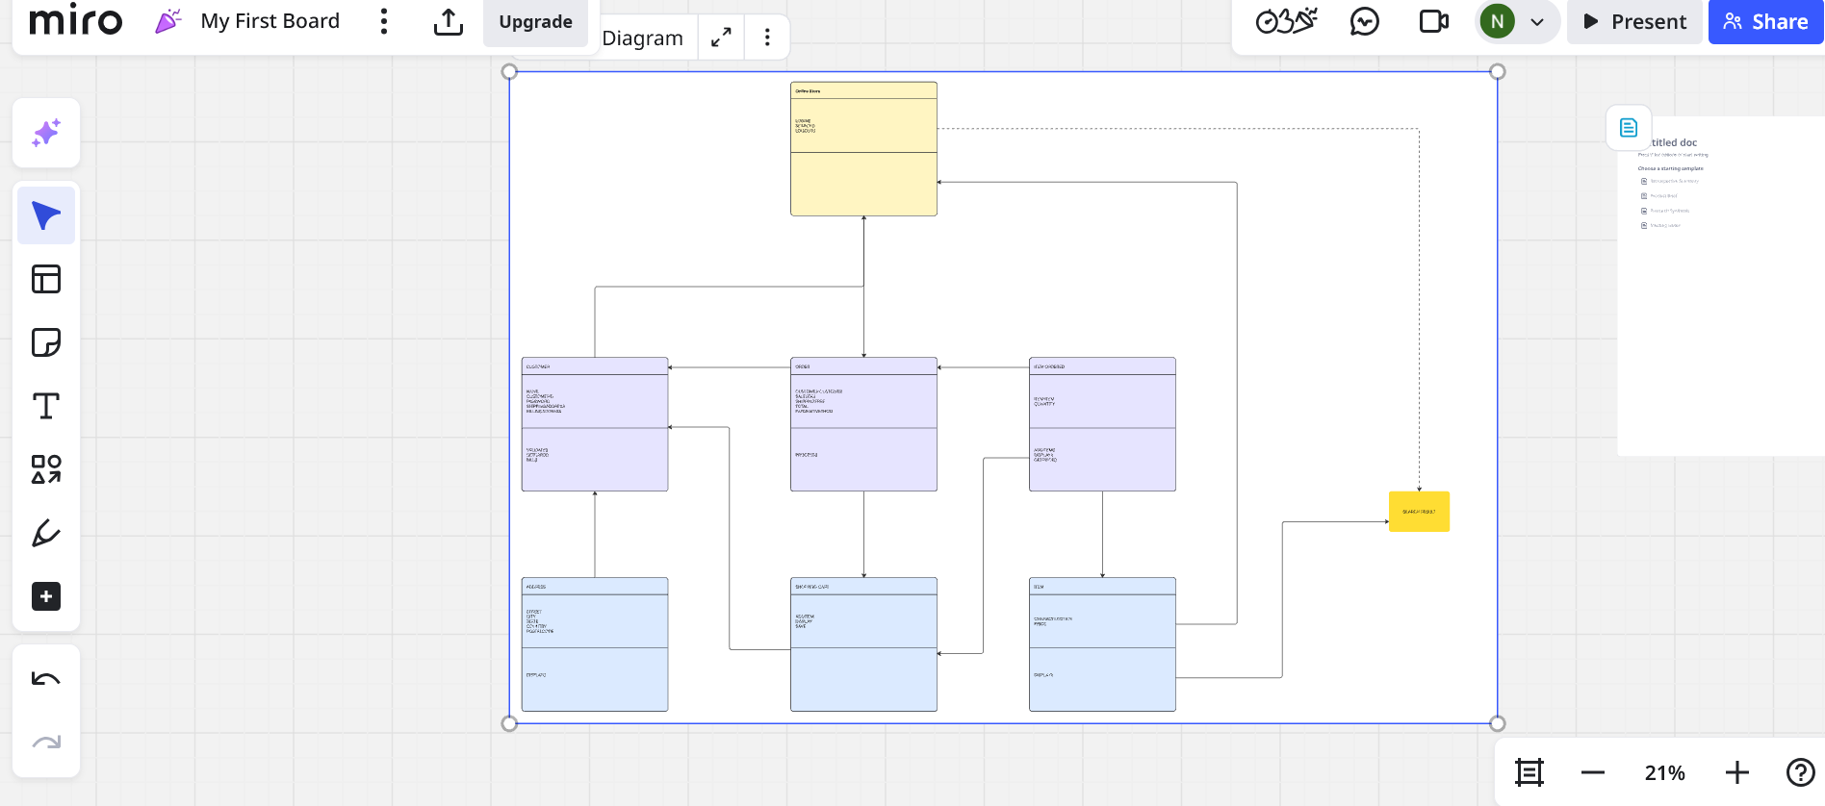

Smartdraw which made this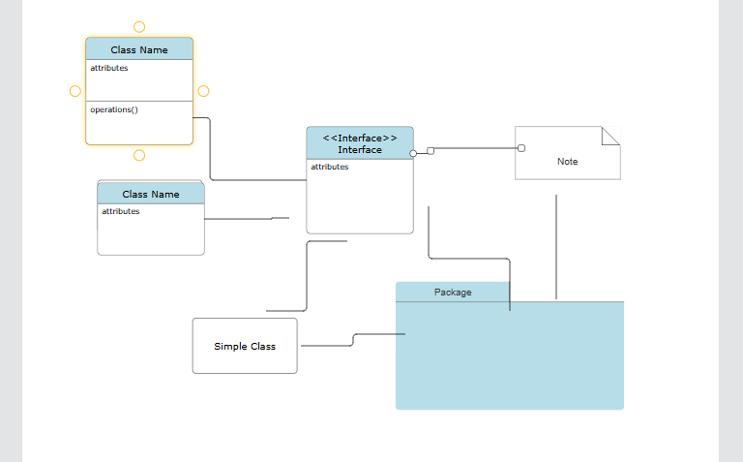

And diagram.net that can create something like this
